[Insert date that you are sending out the release here or use an embargo]
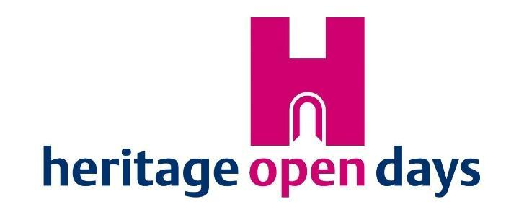
PRESS RELEASE

[Add a cover image that relates to your press release or, if relevant, use the Edible England logo]

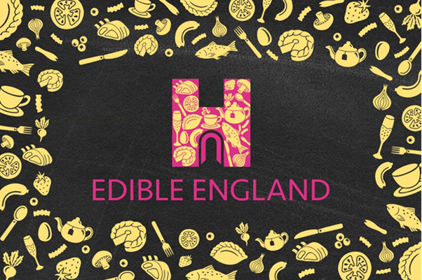
HEADLINE HERE: MAKE IT CLEAR AND EYE-CATCHING – TWO LINES MAXIMUM

Subheader Here: Add context to the headline

[For example…]

Discover more as Heritage Open Days celebrates
Edible England

www.heritageopendays.org.uk
10th – 19th September 2021

- The first paragraph is all-important – journalists may not read any further. They’re busy people, and want the story as quickly as possible. Remember the five W’s:
  - What is happening?
  - Where?
  - When?
  - Who is taking part?
  - Why should the journalist be interested?
  - Also, don’t forget to stress the point that the event is free

- Go into a little more detail in the second paragraph. If you have a quote, include it here. Add some colour to the details in the first paragraph; try and pull out specifics, rather than generics.
  - Instead of “there will be some historical re-enactment”, say; “armour-clad medieval jousting knights will take on the invading armies in a dramatic forty-minute battle.”
  - Instead of “there will be activities for children”, say; “little ones will have fun on a treasure hunt around the garden.”

- Make the third paragraph more factual – give details about the location; its history, other things to see and do. Try and give a little local context to the location; if it is a building, why is it of historic significance?

- Paint a picture with some human stories. Have you got a great tale about one of your volunteers? Have you discovered something new that you want to share with the world? What hidden story will you be revealing?

- Conclude with clear, concise organisational details; is the attraction open on every day of Heritage Open Days? Do you need to book in advance? Is there any restriction on numbers?

ENDS

NOTES TO EDITORS

For media enquiries and images contact:
[Provide one name, a telephone number and an email address. Check and DOUBLE CHECK that these details are correct!]

[If you’re using the About Heritage Open Days section below, add or substitute local details in the final two bullet pointsunts and so on]

About Heritage Open Days
- Heritage Open Days is coordinated and promoted nationally by the National Trust with support from players of People’s Postcode Lottery, and run locally by a large range of organisations (including civic societies, heritage organisations, and local councils, community champions and thousands of enthusiastic volunteers).
- Heritage Open Days is England’s contribution to European Heritage Days, taking place across 50 countries. Other events in the UK are Doors Open Days in Scotland (www.doorsopendays.org.uk); Open Doors Days in Wales (www.cadw.wales.gov.uk/opendoors); European Heritage Open Days in Northern Ireland (www.communities-ni.gov.uk/articles/european-heritage-open-days).
- Heritage Open Days will continue to monitor government guidance and public health advice in respect of the coronavirus pandemic and act in accordance with the requirements. The HODs website will be updated accordingly; please check the site regularly for updates.
- All events are free, including access to many sites that usually charge for admission.
- Heritage Open Days is run locally by a large range of organisations (including civic societies, heritage organisations, and local councils, community champions and thousands of enthusiastic volunteers).
- For further details about the festival, visit www.heritageopendays.org.uk, follow on Twitter @HeritageOpenDay, or subscribe to the newsletter.

[If used, the details about People’s Postcode Lottery below must not be altered, and must appear as a complete section]

About People’s Postcode Lottery
- People’s Postcode Lottery manages lotteries on behalf of 20 Postcode Trusts. People play with their chosen postcodes for a chance to win cash prizes. A minimum of 32% from each subscription goes directly to charities and good causes in Britain and internationally. Players have raised more than £700 million so far. For details of the charities and good causes which are promoting and benefitting from the lottery draws, please visit www.postcodelottery.co.uk/good-causes/draw-calendar
- It costs £10 a month to play and winning postcodes are announced every day. The maximum amount a single ticket can win is 10% of the draw proceeds. For details, please visit www.postcodelottery.co.uk/prizes
- New players can sign up to pay using direct debit by calling 0808 10 9 8 7 6 5. New players who sign up online at www.postcodelottery.co.uk can pay using direct debit, debit card or PayPal.
- Postcode Lottery Limited is regulated by the Gambling Commission under licence numbers: 000-000829-N-102511 and 000-000829-R-102513. Registered office: 2nd Floor, 31 Chertsey Street, Guildford, Surrey, England, GU1 4HD
- Follow us @PPLComms

OPTIONAL
Quotes & Background Information:

[You can use one or more of these quotes from the national team and supporters in your press release. The wording must not be altered and the quotes must be attributed. Alternatively, contact press@heritageopendays.org.uk to request a quote more specific to your area.]

“Heritage Open Days has always included a diverse range of events, but this year we were particularly interested in celebrating our gastronomic heritage with our Edible England theme. Food brings us together, and this year’s festival is a great way to engage with heritage in a way that is accessible - and delicious. From countryside foraging to urban walks, behind the scenes tours to top gardening tips, we’re looking forward to seeing what events our brilliant organisers come up with in 2021.”
Andrew Henderson, Heritage Open Days Marketing & Projects Manager.

“We’re all interested in where we live but we don’t necessarily know the stories behind the buildings and spaces we walk past each day. Our event organisers keep finding creative ways to tell these tales and keep them alive. HODs connects people through shared experiences and this year, that feels more important than ever. It’s also one of the reasons we chose Edible England as our theme. Food brings people together and what we eat and drink is at the heart of much of our culture, our history, our communities, and our daily lives.”
Sarah Holloway, Programme Manager for Heritage Open Days

“Heritage Open Days is about connecting people and nothing brings us together like food and drink. We’re excited to see what innovative events our organisers dish up and we look forward to welcoming people back to some of England’s most vibrant sites. Last year, for the first time, organisers embraced technology to deliver virtual tours, Q&As and behind the scenes experiences. We’re thrilled to encourage both in-person and online events again this year, so organisers and visitors can come together wherever they are.”
Sarah Holloway, Programme Manager for Heritage Open Days

“We’re delighted our players are able to continue to support Heritage Open Days in 2021. The festival has always been about bringing communities together, and this year we’re particularly excited to see how this can be done through food and drink events. It’s certainly a tasty theme!”
Laura Chow, Head of Charities at People’s Postcode Lottery

Factual Information about Heritage Open Days & People’s Postcode Lottery to incorporate into your release:

Heritage Open Days is England’s largest festival of history and culture; every year, thousands of volunteers and supporters organise events that allow us to discover hidden places and try out new experiences. Heritage Open Days is coordinated and promoted nationally by the National Trust with support from players of People’s Postcode Lottery. Every single Heritage Open Days event is free, including access to many sites that usually charge for admission. For details and opening times, visit www.heritageopendays.org.uk.

Our theme for 2021 is Edible England.

What is Edible England?
We want Edible England to encompass the broadest possible spectrum of events and stories, from revealing culinary tastes of the past to going behind-the-scenes of modern production methods – and everything in-between! The theme will also explore the customs and quirks that have developed around what we eat and drink, as well as the fascinating history of some of our regional and national specialties.

Why Edible England?
We are increasingly becoming a nation of foodies and what we eat and drink is at the heart of much of our culture, our history, our communities, and our lives. It's a doorway into hidden histories, regional differences and the myriad cultures around us. It’s a universal language and one of our basic needs; the perfect starting point for another diverse, fun, exciting festival year!

