**Lincolnshire Heritage Open Days 2019**

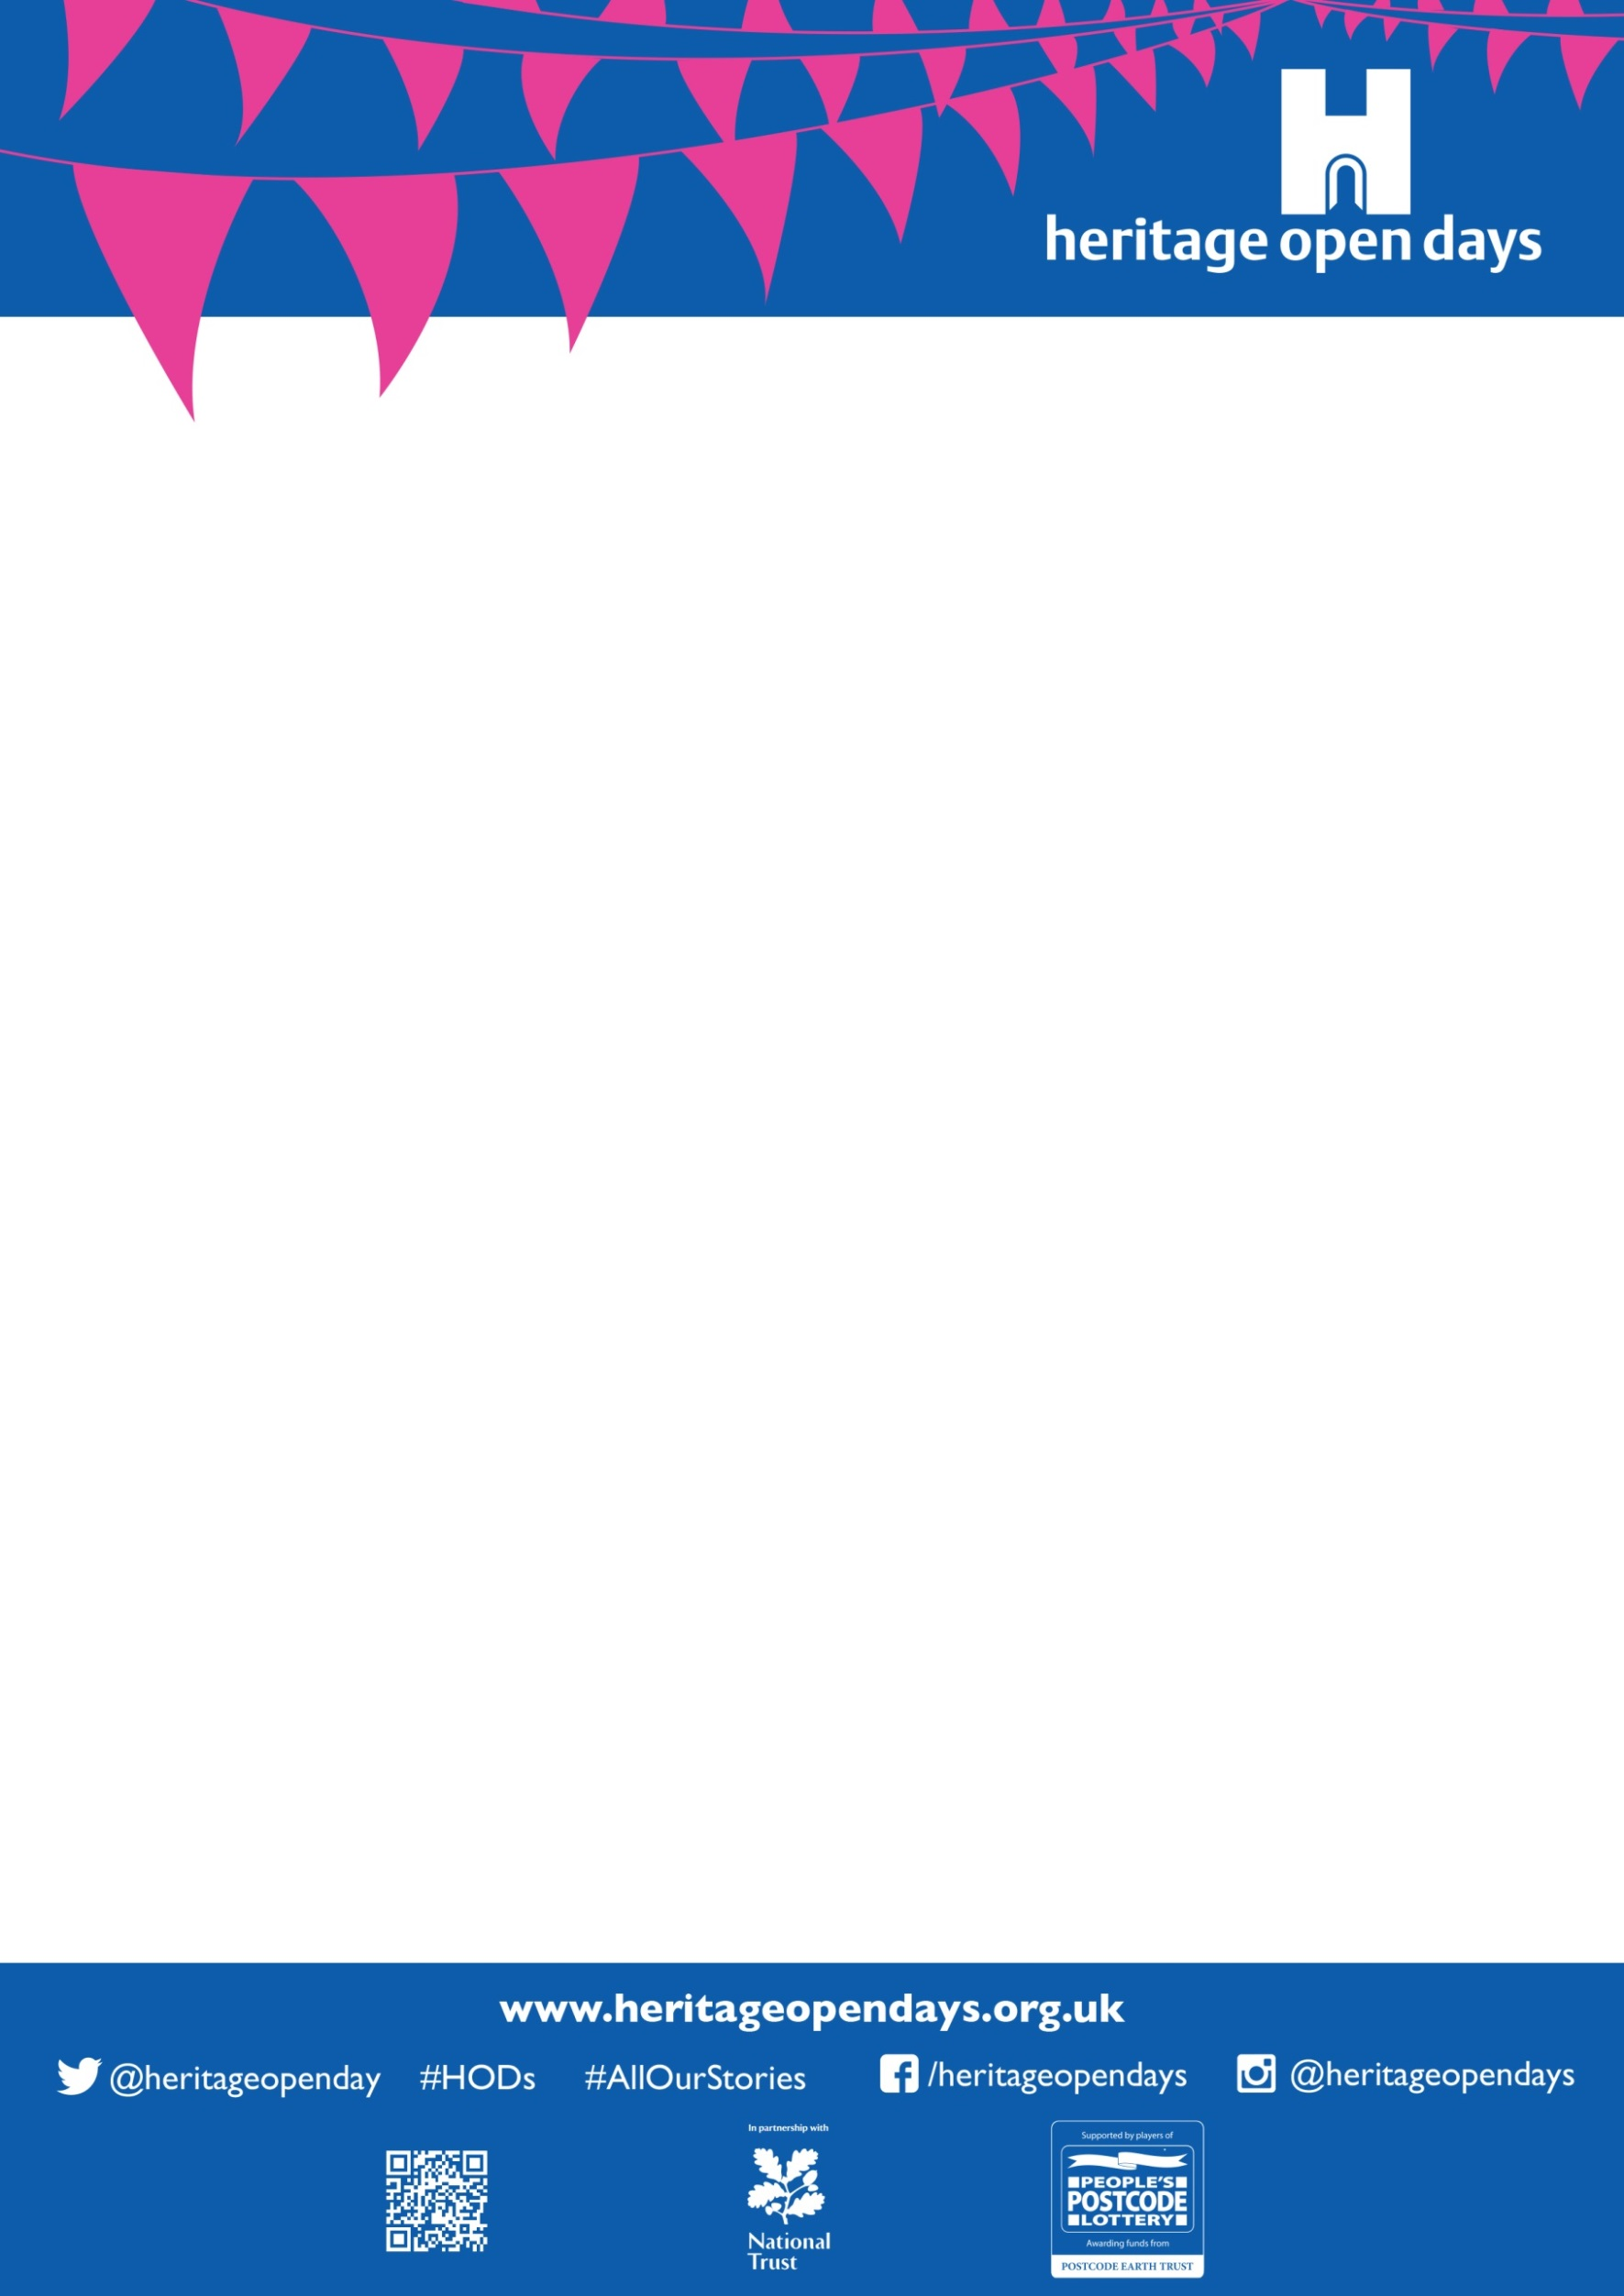

**What is the theme?**: Our theme for 2019 is education in its broadest sense.

**What will the title be?**: Our working title is ‘Lincolnshire Learning, Wisdom and Folklore’ though this may change as we develop our ideas.

**What can I centre the event around?:** Anything that embodies Lincolnshire’s rich history of education traditions. This can be:

* Highlighting your site’s connection to formal education (schools, colleges and universities).
* Describing some local folklore or traditions that were used to teach the young generations of the past.
* Skills demos, where you can showcase some fantastic traditional and/or heritage skills.
* Exhibitions and showcases of research and academic study connected to your site. Have you got some records of research done at the site by someone famous, or new research by a volunteer/member of staff who recently uncovered a lost secret and illuminated it for your visitors?
* Celebrating the great education sessions you currently run to connect life-long learners with heritage at your site.
* Explaining some wondrous inventions or theories which were seeded at your site. E.g. Newton, Banks, Flinders, Harrison etc.
* And much, much more. These suggestions are just the tip of the iceberg so If you have other ideas and want to tell us about them, we’d love to hear it. Just get in touch with our Heritage Open Days Team and we’d be happy to chat them through with you.

**Are you targeting any particular audiences this year?:** Our aim is to get as many people involved in heritage as we can, so don’t have a specific audience to target. We would still like to grow some less developed segments though:

* **Families and children:** They are the key to insuring the future of our fantastic sites, so it would be lovely to see more events with family friendly activities included in the programme, if the sites are suitable for it.
* **Visitors with disabilities:** The festival is all about making heritage accessible for as many people as possible, so if you have a disability-friendly site, or can offer alternative options for those who are living with an impairment or with complex needs then please think about how you could include this in your event. Even something as small as providing copies of information sheets in large print can make a huge difference to someone with a visual impairment, or providing pictures of the upstairs floors to visitors unable to access the upper floors of your site.

**September 13th-22nd Ideas and Information**