INTRODUCTION
Heritage Lincolnshire operates from the Humber to the Wash across the historical county of Lincolnshire.
Our objectives are to advance the education of the public in all matters relating to Lincolnshire’s rich and
diverse heritage and to preserve and investigate that heritage for the benefit of local people and visitors to
the County. We are engaged in these objectives at a time when recognition of the value of heritage is rising
and in a county full of potential in terms of heritage led regeneration. Our vision is to ensure that: The
special character and significance of Lincolnshire’s heritage is understood, valued, conserved and
celebrated for the benefit of local people, visitors and future generations.

The charity has recently raised £2.4 million for the restoration of the Old King’s Head in Kirton and the capital works are now in progress. This historic building, dating from the late 16th century, will be fully refurbished for use as a café and 4* B&B accommodation. Partners include the RSPB (who receive c.58,000 visitors to Frampton Marsh Nature Reserve per year), Visit Boston, Visit Lincoln, Boston Borough Council and other visitor attractions in the area. A detailed business plan is in place for this new venture.

Heritage Lincolnshire has received funding from the National Lottery Heritage Fund, the Wash Fens Leader Fund, Garfield Weston Foundation, the H B Allen Charitable Trust, the Lincolnshire Economic Action Partnership and a range of other charitable donors. The local community has offered tremendous support to the project and helped to raise funds for this new destination venue in their area.

The Old King’s Head in Kirton will be run as a trading arm of Heritage Lincolnshire and any surplus made will be invested back into the charity for its core purposes.

Operational Manager (Full Time, Permanent Post, Salary : £27,000)
This new role within the charity has been created specifically to develop and operate the new business at the Old King’s Head in Kirton. This exciting new venture is in its early stages and this role is an opportunity to lead on the development of all aspects of the hospitality and catering offer within the property. We are looking for a new member of staff with the drive, initiative and enthusiasm that will match our commitment to delivering a high quality catering, accommodation and retail offer within a destination venue. You will have exceptional communication skills, be a team player, and have experience of managing people. The successful candidate will have previous experience of operational management within a leisure/hospitality industry, preferably setting up a new business.

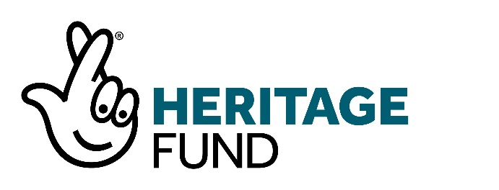

T he Old King’s Head, Kirton
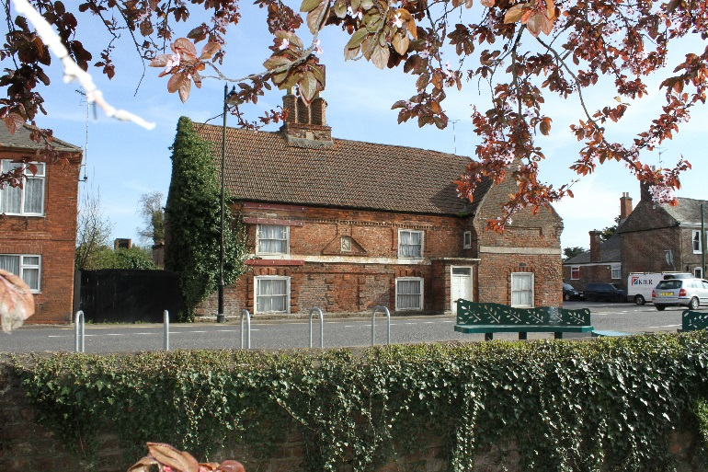
The Old King’s Head is a Grade II listed building situated in the village of Kirton, near Boston. In 2014 the building was identified as ‘at risk’ from dereliction and Boston Borough Council approached Heritage Lincolnshire to find a viable solution for its repair and reuse. The building was purchased by the Trust in 2016 using a loan from the Architectural Heritage Fund and has raised £2.4 million for its redevelopment. A grant of £1.9 million has been secured from the National Lottery Heritage Fund.
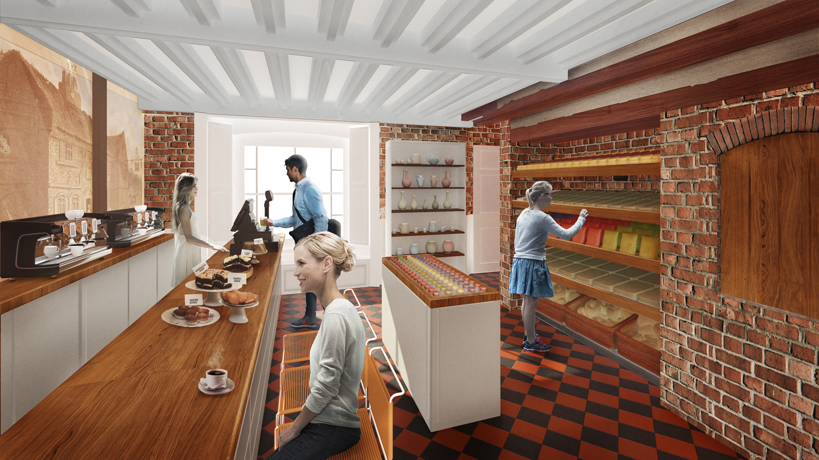
The new business will be based on a café offering a deli inspired menu, using local produce for high quality breakfasts, lunches, and afternoon tea. Monthly evening events will also be offered and a small retail area will offer customers a selection of food, gifts, kitchenware and greetings cards. 4* accommodation is available within the main building, with 4 B&B rooms on the first floor, and within the stable block, in the form of a 2 bedroom self-catering flat. The retail/craft units within units within the stable block will be complementary to the uses of the main building, as will the microbrewery in the outbuilding. This creates a destination that will be needed to attract customers to the area and an annual programme of events and activities will be used to further encourage regular use of the facilities.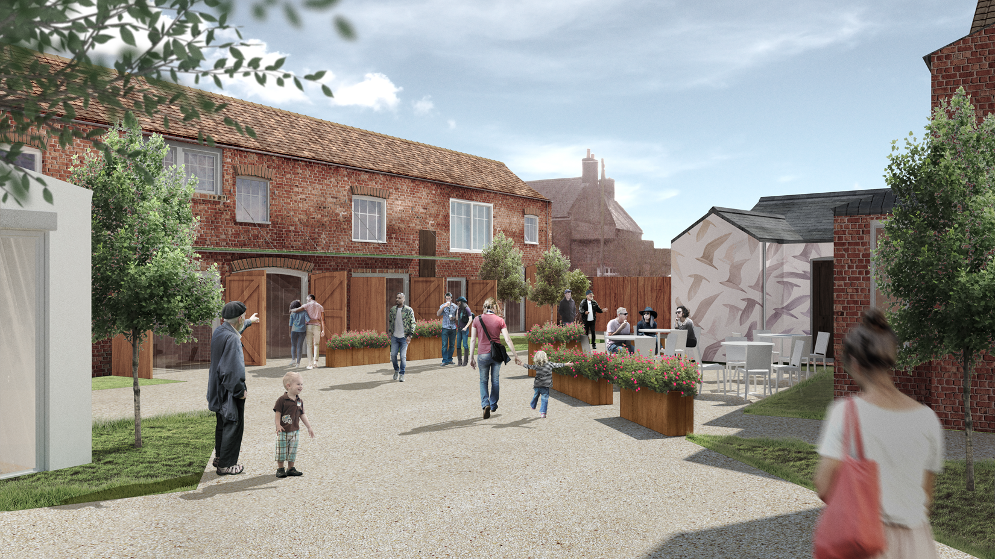
JOB DESCRIPTION
Job title: Operational Manager
Location: The Old King’s Head, Kirton
Responsible to: Chief Executive Officer
Responsible for: Operational staff and volunteers at the Old King’s Head
JOB SUMMARY
To work with the Chief Executive Officer and Senior Management Team to develop the operational plan for the new business at the Old King’s Head in Kirton for a planned opening date of April 2020. To operate the business from opening according to the Business Plan and to deliver the forecast profit targets.
KEY RESPONSIBILITIES
Business Development Stage
Please note that during the business development stage, the Operational Manager will be supported by a Commercial Consultant in the areas highlighted**
- To review the existing business plan for OKH and prepare an action plan inclusive of key milestones to allow commencement of operations in April 2020. Identify key areas of risk to the progression of the operational plan and propose suitable mitigation strategies.**

- Contribute the refinement of the scheme designs between RIBA 4 and completion, working with the professional team and interior designer.**

- Lead on the development of the catering, deli and retail offer at the Old King’s Head to allow the production of the operation plan including but not limited to logistics, staff and resourcing, job descriptions and supplier agreements. Bring expertise and understanding of the local and regional market potential.**

- Lead on the production of lease agreements for all commercial areas and then manage the marketing of the opportunities.**

- Lead on the partnership opportunities and secure advantageous partnerships with regional heritage and cultural partners.**

- Heritage Lincolnshire is appointing a PR firm to promote both the project and the business from now until post-opening. The Operational Manager is to be the lead / key contact representing Heritage Lincolnshire with the PR firm.

- Act as lead for the activity programme of events and activities as per the approved Activity Plan.

- Record all relevant data that can be used for evaluation purposes on a regular basis and provide data to the project evaluator in a format and at intervals to be agreed.

- Collaborate with volunteer group, professional team, project partners and Heritage Lincolnshire staff and local community as required.

- To undertake tasks as required by the Chief Executive Officer as appropriate.

Business delivery stage

- To run the business efficiently with a focus on meeting the expectations and needs of customers and clients.
- To implement all operational policies and procedures.
- To manage recruitment, training and development of staff and volunteers.
- To promote a company culture that encourages top performance and high morale.
- To undertake all logistical planning and ordering for the business.
- To oversee budgeting, reporting, planning, and auditing.
- To deliver an annual programme of events and activities that will enhance the ‘destination value’ of the Old King’s Head.
- To ensure all legal and regulatory documents are filed and monitor compliance with laws and regulations.
- To work with the board of directors to track performance targets and to set development plans for the business, planning for short and long-term goals.
- To identify and address problems and opportunities for the company.
- To develop and maintain advantageous partnerships with other leisure, retail and cultural organisations in the area.
- To support staff and volunteers in delivering a high quality customer experience.
Benefits of working for Heritage Lincolnshire
Heritage Lincolnshire is a well-regarded and established charity employing 35 members of staff, over 250 volunteers and working in partnership with a wide range of organisations. As a small team with a huge amount of skills, experience and enthusiasm, we work collaboratively to deliver a wide range of projects, services and activities.
Benefits include:
- Pension scheme including an employer’s contribution of 5% of gross annual salary
- 30 days holiday per year inclusive of bank holidays (increasing to 33 days after 2 years’ service)
- Flexible working hours with time of in lieu for any additional hours worked
- Mileage and expenses payments
- Childcare voucher scheme
- Continued Professional Development

The restored property at the Old King’s Head includes a 2 bedroom flat within the stable block, which is currently within the business plan as a short term holiday let, but could be used as manager’s accommodation as part of a re-negotiated remuneration package.
PERSON SPECIFICATION
 | ESSENTIAL | DESIRABLE
Education/Training/Qualifications | - No essential requirement as assessment equally weighted on experience. | - Qualification in 1 or more of the following: hospitality & catering, tourism, business studies and marketing.  - H&S Qualification
Experience | - Experience of hospitality and catering sector.  - Ability to demonstrate performance in a relevant business.  - Management of People focussed services.  - Understanding of both high quality customer service and principles.  - Experience of business development. | - Ability to demonstrate track record in partnership working.  - Experience of the cultural heritage sector.
Competencies | - Well-developed interpersonal and communication skills  - Excellent organisational skills  - Innovative and proactive in the delivery of business objectives and targets.  - Excellent team player  - Ability to work under pressure  - Use of Microsoft programmes | - Ability to engage with a range of clients, funding partners and supporters.  - Aptitude for working with volunteers and making use of their skills and experience.
Values and attitudes | - Flexible according to the needs of the business  - Smart appearance  - Confidence  - Enthusiastic  - Committed to equal opportunities

